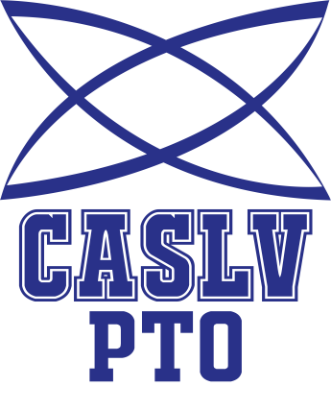
Coral Academy of Science PTO
Notice of Public Meeting Agenda
Monday, January 22, 2018 ~ 6:20pm
Coral Academy of Science – Sandy Ridge
1051 Sandy Ridge Ave, Henderson, NV 89052
Members: President - Alisa Low​, Secretary - Stacey Fuqua, Treasurer - Greg Darrough, Tamarus VP Fundraising – Amy Aguilar, Tamarus co-VP Parent/ Staff - Kerri Mathes & Lorena Roth, Windmill VP Fundraising - Samaria English

- Call to Order: Introduction of interim President

- Treasurers Report: Greg Darrough

- Officer & Committee Reports:

Fundraising Reports, Review Discussion

School Events Review & Discussion
Golf Tournament Review & Discussion

Social Media Review & Discussion

Grant Review & Discussion

- Additional Member Discussion Items
- Public Discussion
- Next Meeting Date Announcement
- Adjournment

